Unit 4: Financial Sector

Money, banking, and financial markets

Topic 1: Definition of financial assets: money, stocks, bonds

Difficulty Level 1
- Which asset is a share in the ownership of a company held by a shareholder?
  - Bond
  - Dividend
  - Mortgage
  - Mortgage-backed security
  - Stock
- What is the benefit when a household purchases a bond?
  - The promise of future income
  - A share of ownership of a company
  - The ability to exchange the bond for goods and services
  - Ownership of a piece of property
  - Dividend payments from a corporation

Difficulty Level 2
- Which of the following is a financial asset?
- A share of ownership in an auto company
- An apartment building
- A textile factory
- A government bond
  - I only
  - II only
  - I and IV only
  - II and III only
  - I, II, III, and IV

- If Eric is using money to purchase gasoline for his car he is using money as
  - a unit of account.
  - a medium of exchange.
  - a transfer of profit
  - a store of value
  - an interest bearing asset
- What determines the real value of the United States dollar?
  - The quantity of money held as bank reserves
  - The money multiplier
  - The value of the gold backing the money supply
  - The goods and services the dollar will buy
  - The interest rate in the loanable funds market

- As an economy replaces gold coins with notes that represent gold coins held in reserve, its money supply is evolving from
  - fiat money to commodity money
  - commodity money to fiat money
  - commodity-backed money to fiat money
  - commodity-backed money to commodity money
  - commodity money to commodity-backed money

Topic 2: Time value of money (present and future value)

Difficulty Level 2
- If you loan $100 today, what is the future value of the loan one year from now at an annual interest rate of 8%?
  - $92
  - $100
  - $102
  - $108
  - $116

Difficulty Level 3
- If the interest rate is 10%, the present value of $1.10 paid to you one year from now is:
  - $0.89
  - $0.90
  - $1.00
  - $1.10
  - $1.21
- If you loan $100 at a 5% annual interest rate, what is the real value of the loan one year from now if the inflation rate is 3%?
  - $95
  - $100
  - $102
  - $103
  - $105

Topic 3: Measures of money supply

Difficulty Level 1
- Which of the following are not counted in the money supply of the United States?
  - currency
  - coins
  - checkable deposits
  - demand deposits
  - pure gold coins
- Which of the following includes only the most liquid assets?
  - M1 money
  - M2 money
  - stocks and bonds
  - mortgage-backed securities
  - mutual funds

Difficulty Level 2
- Which of the following constitutes the largest component of the M1 money supply?
  - currency
  - coins
  - savings deposits
  - checkable deposits
  - traveler’s checks
- What is the effect of a withdrawal of $500 from a checking account on the M1 measure of the money supply?
  - It does not change.
  - It increases by $500.
  - It increases by less than $500.
  - It decreases by $500.
  - It decreases by less than $500.
- Nancy transfers $2000 from her savings account to her checking account. What is the effect on the M1 measure and the M2 measure of the money supply?
M1 M2
  - Increases by $2000 Increases by $2000
  - Increases by $2000 Decreases by $2000
  - Decreases by $2000 No change
  - No change Decreases by $2000
  - Increases by $2000 No change
Use the table below to answer the following question.
Assets
Currency  Traveler’s checks  Short time deposits (CDs)  Municipal bonds  Savings deposits  Money market funds  Checkable deposits  Gift cards | $25  $5  $10  $60  $30  $20  $70  $50
- According to the table, what is the value of M1 and M2?
M1 M2
  - $100 $100
  - $100 $160
  - $130 $160
  - $160 $210
  - $160 $220

The Fractional Reserve Banking System

Topic 4: Banks and creation of money

Difficulty Level 1
- What are bank reserves?
  - Deposits that are held in the form of gold reserves
  - The sum of all loans a bank makes to borrowers
  - The value of investments a bank keeps in excess of the value of deposits
  - The fraction of deposits kept as currency or on deposit at the Federal Reserve
  - The value of owner’s equity in the bank

- The reserve ratio is the fraction of deposits that banks
  - have loaned to borrowers.
  - invest in securities.
  - hold as reserves.
  - are required to loan.
  - hold as gold reserves.

Difficulty Level 2
- If the required reserve ratio is 10% and $200 is deposited into a bank, by how much can that bank increase its loans?
  - $10
  - $20
  - $180
  - $190
  - $200
- If the required reserve ratio is 10 percent, what is the maximum change in demand deposits possible in the banking system if Denise deposits $25 into her checking account?
  - $10
  - $25
  - $50
  - $250
  - $400
- What action must a bank take to create money?
  - Lend excess reserves to customers
  - Print currency at the Federal Reserve
  - Keep all deposits in reserve
  - Use all deposits to purchase stocks and bonds
  - Purchase Treasury bills from the government
- If the reserve requirement is 20 percent, then $50 worth of excess reserves in the banking system can lead to a maximum expansion of the money supply equal to
  - $20
  - $50
  - $100
  - $250
  - $500
- If the public increases its desire to hold money as currency, what will the effect on the banking system?
  - Banks would be more able to control interest rates.
  - Banks would be less able to control interest rates.
  - Banks would be more able to expand credit.
  - Banks would be less able to expand credit.
  - Banks would be more able to increase reserves.
- A bank with no excess reserves receives a $200 deposit from a new customer. If the required reserve ratio is 20 percent, this bank now has excess reserves equal to
  - $20
  - $40
  - $80
  - $160
  - $200
- A bank with no excess reserves receives a $10,000 cash deposit from a new customer. If the required reserve ratio is 20 percent, what is the maximum amount by which this bank may increase its loans?
  - $2,000
  - $8,000
  - $10,000
  - $20,000
  - $40,000
Use the table below to answer the following question.
Assets |  |  | Liabilities
Required reserves: | $15,000 |  | Demand Deposits: | $100,000
Excess reserves: | 5,000
Loans: | 80,000
- According to the information in the table above, what is the required reserve ratio in this economy?
  - 5%
  - 15%
  - 20%
  - 80%
  - 100%

Difficulty Level 3
- Upon receiving a demand deposit of $1000 a bank’s excess reserves increased by $850. The required reserve ratio must be
  - 5%
  - 10%
  - 15%
  - 85%
  - 150%
Use the table below to answer the following question.
Assets |  |  | Liabilities
Reserves: | $13,000 |  | Demand Deposits: | $100,000
Securities | 75,000
Loans: | 12,000

- A bank is facing the conditions given in the table above. If the reserve requirement is 11 percent and the bank does not sell any of its securities, what is the maximum additional amount that this bank can loan?
  - 0
  - $1430
  - $2000
  - $11,000
  - $13,000
- If the reserve requirement is 10 percent but banks voluntarily keep some excess reserves, a $5,000 increase in new reserves will result in
  - an increase in the money supply of $5,000
  - an increase in the money supply of $50,000
  - an increase in the money supply of less than $50,000
  - a decrease in the money supply of $50,000
  - a decrease in the money supply of more than $50,000

The Money Market

Topic 5: Money demand

Difficulty Level 1
- The opportunity cost of holding money is
  - the nominal interest rate on less liquid assets
  - the federal funds rate
  - the discount rate
  - the mortgage rate
  - zero

Difficulty Level 2
- Why does the demand for money increase when national income increases?
  - The money supply increases
  - The budget deficit decreases
  - Interest rates increase
  - Spending on goods and services increases
  - Imports decrease
- How does an increase in price level affect the money market?
  - Money demand increases
  - Money demand decreases
  - Money demand does not change
  - Money supply decreases
  - Money supply increases
- An increase in the use of cell phones to provide electronic payment in stores will likely result in
  - an increase in money demand
  - a decrease in the money supply
  - an increase in nominal interest rates
  - a decrease in money demand
  - an increased opportunity cost for holding money
- Assume that there are no fees to access an ATM. If Congress then decides to impose a $5 tax on each ATM transaction, what will be the likely effect?
  - The use of ATMs will increase
  - Money demand will decrease
  - Sellers will only accept cash as payment
  - Price level will increase
  - Money demand will increase

- How will households and firms react to an increase in the nominal interest rate for interest-bearing bank accounts?
  - The quantity of money demanded will increase
  - The quantity of money demanded will remain constant
  - The quantity of money demanded will decrease
  - The amount of money used for transactions will increase
  - The opportunity cost of holding money will decrease

Topic 6: Money market and the equilibrium nominal interest rate

Difficulty Level 2
- If the public decides to increase its holdings of currency, which of the following is most likely to increase?
  - bank deposits
  - investment spending
  - price level
  - the interest rate
  - the unemployment rate
- Which of the following will most likely occur in an economy if the quantity of money demanded is greater than the quantity of money supplied?
  - The money demand curve will shift to the left
  - The money demand curve will shift to the right
  - Interest rates will increase
  - Interest rates will decrease
  - Excess reserves will decrease
Use the graph below to answer the following questions.
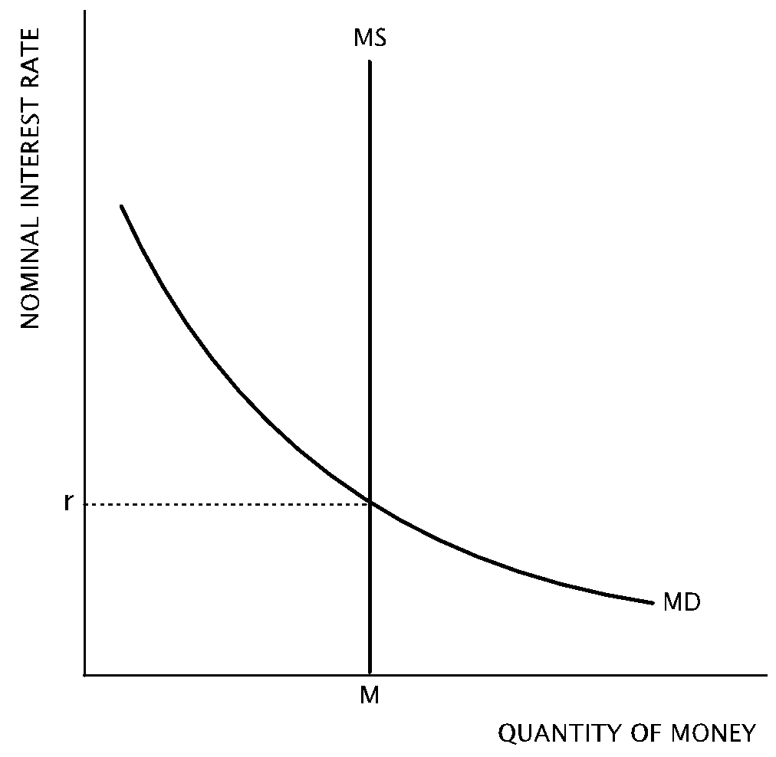
- According to graph above, what is the likely result if there is an increase in the money supply?
  - the nominal interest rate will decrease
  - the nominal interest rate will increase
  - money demand will increase
  - the quantity of money demanded will decrease
  - the equilibrium quantity of money will decrease
- According to the graph, which of the following changes will result in a decrease in the equilibrium nominal interest rate?
- An expansionary monetary policy
- An decrease in price level
- An increase in real gross domestic product
  - I only
  - II only
  - III only
  - I and II only
  - II and III only

Loanable Funds Market

Topic 1: Supply of and demand for loanable funds

Difficulty Level 1
- What causes firms to demand a higher quantity of loanable funds at a lower real interest rate?
  - The government offers subsidies to firms that borrow at lower interest rates
  - There is a higher rate of return on investments made at lower interest rates
  - There is a lower rate of return on investments made at lower interest rates
  - Firms only borrow funds at low interest rates
  - Banks cannot loan to firms at high interest rates
- The loanable funds model demonstrates the interaction of _______________________ in determining the equilibrium real interest rate.
Which of the following completes the sentence above?
  - households and firms
  - government and households
  - price level and output
  - savers and borrowers
  - foreign and domestic consumers

Difficulty Level 2
Use the graph below to answer the following questions.
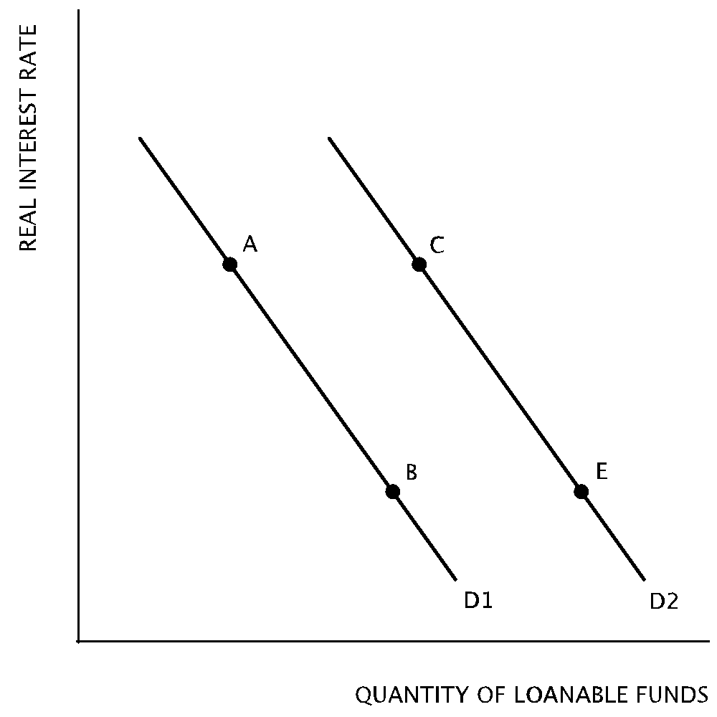
- Which of the following will most likely produce a movement from Point A on D1 to Point C on D2?
  - Corporate profits are expected to decline in the future
  - An increase in capital inflows from other nations
  - The federal government has a budget surplus
  - Households are encouraged to increase their savings
  - Firms become more optimistic about future business opportunities
- A movement from Point E on D2 to Point B on D1 will most likely be the result of
  - increased business opportunities after new computer technology is introduced.
  - a decrease in government spending that leads to a budget surplus.
  - a decrease in taxes that leads to a government budget deficit.
  - a decrease in private savings.
  - an increase in the marginal propensity to consume.
- Due to decreased confidence in the financial system, people have increased their savings in foreign financial institutions. What is the likely result on the domestic loanable funds market?
  - The demand for loanable funds will increase
  - The demand for loanable funds will decrease
  - The supply of loanable funds will increase
  - The supply of loanable funds will decrease
  - The domestic loanable funds market will be unaffected

Difficulty Level 3
- In the market for loanable funds, the equilibrium interest rate is 4% and the equilibrium quantity of loanable funds is $100 billion. What will be the likely result if financial institutions offer an interest rate of 6%?
  - There will be an increase in the quantity of loanable funds demanded.
  - There will be an increase in borrowing.
  - The quantity of loanable funds supplied will be more than $100 billion.
  - The quantity of loanable funds demanded will be greater than the quantity supplied.
  - The loanable funds market will remain in equilibrium.

Topic 2: Equilibrium real interest rate

Difficulty Level 2
- If firms believe that business opportunities will decrease in the future, the demand for loans and the real interest rate in the loanable funds market will likely change in which of the following ways in the short run?
Demand for Loans Real Interest Rate
  - Decrease Not change
  - Decrease Increase
  - Increase Increase
  - Increase Decrease
  - Decrease Decrease
Use the diagram below to answer the following questions.
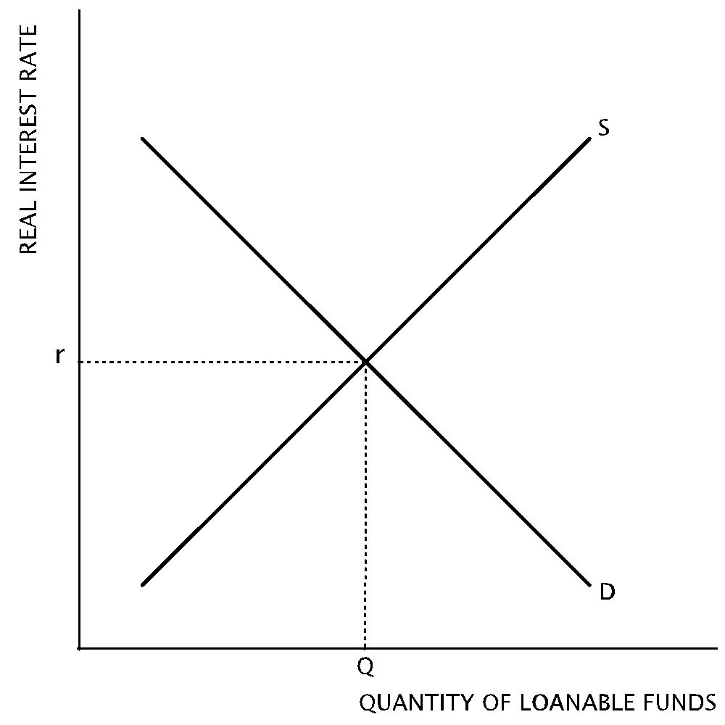
- According to the graph, an increase in savings by households will
  - increase the demand for loanable funds and increase the real interest rate
  - decrease the demand for loanable funds and decrease the real interest rate
  - increase the supply of loanable funds and decrease the real interest rate
  - decrease the supply of loanable funds and increase the real interest rate
  - not affect the loanable funds market
- Which of the following changes will cause an increase in the real interest rate in the loanable funds market?
  - The government launches a campaign to encourage the public to increase their savings.
  - Firms are optimistic about the housing market and increase construction projects
  - The national government reports its second consecutive annual budget surplus
  - Foreign savers increase their deposits in domestic financial institutions
  - The government increases the money supply

Topic 3: Crowding out

Difficulty Level 1
- Which of the following statements best describes crowding out?
  - An increase in the money supply.
  - An increase in net exports resulting from a depreciation of the currency.
  - An increase in private borrowing subsidized by the government.
  - A decrease in private investment resulting from government borrowing.
  - An increase in the supply of loanable funds due to increased public and private savings.
- Government borrowing causes crowding out because
  - lower interest rates increase private sector investment
  - higher interest rates decrease private sector investment
  - higher interest rates increase private sector investment
  - a larger money supply increases private sector investment
  - a smaller money supply decreases private sector investment

Difficulty Level 2
- The national government has increased deficit spending on goods and services. In the long-run, which of the following changes would most likely result from this policy?
Real Interest Rate Investment
  - Decrease Increase
  - Decrease Decrease
  - No change Increase
  - Increase Decrease
  - Increase No change
- Which of the following changes will most likely result in crowding out?
  - Increase in trade deficit
  - Increase in labor productivity
  - Decrease in government spending
  - Increase in budget deficit
  - Decrease in commodity prices
- Expansionary fiscal policies adopted to counteract a recession tend to result in
  - less public spending
  - lower prices
  - a high rate of economic growth
  - higher interest rates
  - decreased investment by foreign companies

Central bank and control of the money supply

Topic 1: Tools of central bank policy

Difficulty Level 1
- Which of the following is not a monetary policy tool of the Federal Reserve System?
  - setting the reserve requirement
  - open market operations
  - minting bills and coins
  - open market operations
  - regulating the banking system
- The discount rate refers to the price the Federal Reserve System charges for:
  - goods and services
  - loans to state governments
  - loans to banks
  - newly printed currency
  - U.S. Treasury bills

Difficulty Level 2
- Which of the following best describes the result of a sale of U.S. Treasury bills on the open market by the Federal Reserve?
Money supply Interest rates
  - Increase Increase
  - Increase Decrease
  - No change Increase
  - Decrease Decrease
  - Decrease Increase
- What will likely occur if the Federal Reserve acts to increase the money supply with open market operations?
  - Bank reserves will decrease.
  - Bond prices will increase.
  - The discount rate will increase.
  - The federal funds rate will increase.
  - The government budget will move toward surplus
- Which combination of actions by the Federal Reserve System will cause the greatest increase in the money supply?
Reserve requirement Discount rate
  - Increase Increase
  - Decrease No change
  - Increase Decrease
  - No change Decrease
  - Decrease Decrease

- Which of the following best describes the result of a decrease in the discount rate?
  - The demand for money increases and interest rates increase
  - The demand for money decreases and interest rates decrease
  - The supply of money increases and interest rates decrease
  - The supply of money increases and interest rates increase
  - Both the demand for money and the supply of money increase and interest rates increase
- What change in monetary policy can the Federal Reserve enact to reduce the ability of the banking system to create money?
  - Decreasing the federal funds rate
  - Buying government bonds on the open market
  - Decreasing income taxes
  - Decreasing the reserve requirement
  - Increasing the discount rate
- Contractionary monetary policy can affect the economy through which of the following chains of events?
  - Decreasing government spending lowers the interest rate, which lowers consumption.
  - Increasing the discount rate lowers the real interest rate, which raises investment.
  - Selling bonds decreases the money supply, which increases the interest rate.
  - Increasing taxes increases the reserve requirement, which decreases investment.
  - Buying bonds increases the money supply, which lowers the interest rate.

Topic 2: Quantity theory of money

Difficulty Level 1
- If nominal gross domestic product in an economy is $1,200 and the money supply is $300, what is the velocity of money?
  - 3
  - 4
  - 12
  - 40
  - 300
- According to the quanity theory of money, if there is a significant increase in the money supply, there will be an increase in
  - the unemployment rate
  - the real interest rate
  - the price level
  - real output
  - the velocity of money

Difficulty Level 2
- If the velocity of money is assumed to be stable in the short-run, the quantity theory of money contends that a decrease in the money supply will lead to a proportional
  - increase in the unemployment rate
  - increase in the price level
  - increase in the nominal interest rate
  - increase in the real interest rate
  - decrease in nominal output

Topic 3: Real v. nominal interest rates

Difficulty Level 1
- If a lender expects a real interest rate of 5 percent and the inflation rate is expected to be 3 percent, what is the nominal interest rate?
  - 2 percent
  - 3 percent
  - 5 percent
  - 8 percent
  - 15 percent

Difficulty Level 2
- A worker’s nominal wage rate has increased from $8 to $10 per hour, while at the same time the general price level has increased by 10 percent. What is the effect on the worker’s real wage?
  - It has decreased by 10 percent
  - It has decreased by 15 percent
  - It has increased by 10 percent
  - It has increased by 15 percent
  - It has not changed
- Assume that the nominal interest rate is 8 percent. If the real interest rate is 5 percent, the expected inflation rate is
  - 3 percent
  - 4 percent
  - 5 percent
  - 8 percent
  - 13 percent

- Anna lends $100 to Emily for one year. Anna expects the price level to increase by 8 percent over that year. If Anna wants to maintain the real value of her $100, she should demand payment from Emily of
  - $92
  - $100
  - $108
  - $110
  - $192

Answers

Money, banking, and financial markets

Topic 1: Definition of financial assets: money, stocks, bonds

Difficulty Level 1
- Correct answer: E
A stock represents a share in the ownership of a corporation. These shares are bought and sold in the stock market.
Incorrect Answer
These shares can be bought and sold in a market. Try eliminating a few answers before choosing.
- Correct answer: A
A bond is a type of I.O.U. in which the purchaser is promised future income in addition to a return of the face value of the bond.
Incorrect Answer
Do not confuse bonds, stocks, mortgages, and money—they represent different types of assets.

Difficulty Level 2
- Correct answer: C
Financial assets include money, stocks, bonds, and other non-physical assets. The apartment building and factory, along with productive physical capital like machines and tools, represent physical assets.
Incorrect Answer
Consider that only two of these examples are physical things.
- Correct answer: B
When money is being exchanged for goods or services, it is acting as a medium of exchange.
Incorrect Answer
Try to eliminate some answers that do not quite fit. For example, since Eric is using his money to buy gasoline, he is not storing value since he is giving the money to somebody else.
- Correct answer: D
Money is anything that can be used as a medium of exchange, and its real value is the goods and services for which it can be exchanged. A tempting answer here is the value of the gold backing the money supply, but remember that U.S. currency is fiat money, backed by the its official status as money rather than by any commodity.
Incorrect Answer
In economics, when the term “real value” is used, it refers to purchasing power, i.e. what can actually be purchased.
- Correct answer: E
Gold coins are a commodity that can be used as money or for another purpose, such as making jewelry. When the money supply is changed to notes that represent gold coins held in reserve, those notes are known as commodity-backed money.
Incorrect Answer
A commodity is something that can be consumed or used to produce another good. Considering this definition, then pieces of gold are a commodity.

Topic 2: Time value of money (present and future value)

Difficulty Level 2
- Correct answer: D
The formula for future value is:
$$Future value= Present value × {(1+interest rate)}^{\# of years}$$
In this case, the math is simple: $100 X 1.08 = $108.
Incorrect Answer
Try using the formula for future value:
$$Future value= Present value × {(1+interest rate)}^{\# of years}$$

Difficulty Level 3
- Correct answer: C
The present value is equal to the future value one year from now ($1.10) divided by one plus the interest rate, which works out to $1.10/1.10, or $1.Another way to think of this is to ask “How much money must I save at 10% interest for one year to equal $1.10?”
Incorrect Answer
Try rephrasing the question as, “How much money must I save at 10% interest for one year to equal $1.10?”
- Correct answer: C
You can use the formula for future value:
$$Future value= Present value × {(1+interest rate)}^{\# of years}$$
There is one caveat—you must use the real interest rate of 2%, which is the nominal rate of 5% subtracted by the 3% rate of inflation.
Incorrect Answer
You can use the formula for future value:
$$Future value= Present value × {(1+interest rate)}^{\# of years}$$
However, be sure to account for the 2% inflation rate, which will decrease the real future value of the loan.

Topic 3: Measures of money supply

Difficulty Level 1
- Correct answer: E
Gold is not a part of the money supply, although many years ago the United States issued paper currency that was backed by gold reserves.
Incorrect Answer
Use M1 as your measure of what is included and excluded from the money supply.
- Correct answer: A
M1 money includes only the most liquid assets. Currency, traveler’s checks, and checkable deposits are the most easily and quickly convertible to a medium of exchange.
Incorrect Answer
Liquidity describes an asset that is easily and quickly convertible into a medium of exchange.

Difficulty Level 2
- Correct answer: D
The M1 money supply consists of currency and coin in circulation, traveler’s checks, and checkable deposits. Checkable deposits constitutes the largest of these components.
Incorrect Answer
First eliminate any answer that is not a part of the M1 money supply to narrow your answer.
- Correct answer: A
The withdrawal has no effect on the M1 measure of the money supply because both cash and checkable deposits are part of M1. The $500 withdrawal merely changes the composition of the money.
Incorrect Answer
There are two forms of money in use here: checkable deposits and cash. Are these forms a part of M1, M2, or both?
- Correct answer: E
All the components of M1 are included in M2.. When Nancy withdraws the $2000 from savings and moves it to her checking account, it becomes both M1 and M2. Since it was already counted in M2 initially, there is no change in M2. When the money arrives in the checking account, M1 increases by $2000.
Incorrect Answer
Be sure to trace the movement of money carefully. Remember that all components of M1 are included in M2, but not all components of M2 are included in M1.
- Correct answer: B
M1 includes currency, traveler’s checks, and checkable deposits, which totals $100, and M2 includes M1, short time deposits, savings deposits, and money market funds, which totals $160.
Incorrect Answer
It may be helpful to scribble M1 next to each component of that measurement and M2 next to each of its components as well. Remember that all the components of M1 are also in M2.

The Fractional Reserve Banking System

Topic 4: Banks and creation of money

Difficulty Level 1
- Correct answer: D
When a bank deposit is made, banks often loan or invest much of the deposit. The fraction of the deposit that is held as a liquid asset like currency or held in deposit at the Federal Reserve are called bank reserves.
Incorrect Answer
It is important to understand that banks do not hold all of the cash a customer deposits in a vault.
- Correct answer: C
The reserve ratio measures the ratio of reserves to deposits. For instance, if $100 has been deposited and the bank holds $20 in reserve, then the reserve ratio is 0.2.
Incorrect Answer
Consider that a bank reserves are deposits kept as currency or on deposit at the Federal Reserve.

Difficulty Level 2
- Correct answer: C
The bank must hold 10% of $200, or $20, in reserve. It can loan out the remaining $180 if it chooses to.
Incorrect Answer
The required reserve ratio indicates what percentage of deposits must be held as reserves. What remains can be loaned.
- Correct answer: D
Since the required reserve ratio is 10 percent, the money multiplier equals 1/0.1, or By multiplying the $25 deposit by this money multiplier, we can determine that the maximum possible change in demand deposits in the banking system is $250.
Incorrect Answer
The first step in determining the answer is to calculate the money multiplier. The formula fo rthe money multiplier is $\frac{1}{required reserve ratio}$ .
- Correct answer: A
To create money a bank must issue a loan. When a deposit is made at the bank, currency is converted into a demand deposit. In order to increase the money supply, some of that deposit is converted into a liquid asset such as currency and loaned to a customer.
Incorrect Answer
When a deposit is made, currency is taken out of circulation and converted into a demand deposit. How can a bank use that currency be used to add to the money supply.
- Correct answer: D
The maximum expansion of the money supply through the multiple deposit expansion process can be determined using the money multiplier: $\frac{1}{required reserve ratio}$ . In this case, the money multiplier is 5, which is multiplied by the $50 of excess reserves to get $250.
Incorrect Answer
The maximum expansion of the money supply through the multiple deposit expansion process can be determined using the money multiplier: $\frac{1}{required reserve ratio}$ .
- Correct answer: D
The more money that is deposited at a bank, the greater the amount of money that can be loaned by the bank. If the public increases its money holdings, less money will be deposited in banks, reducing the ability of banks to expand credit.
Incorrect Answer
If the public is holding more money as currency, then less money is being deposited into banks. How does this change the abilities of the banking system?
- Correct answer: D
Since the bank has no excess reserves to begin with, a $200 deposit will create $160 of excess reserves because 20% of the $200 deposit, or $40, fulfills the reserve requirement.
Incorrect Answer
This bank is required to reserve 20% of all deposits. How much must be reserved of the $200 deposit? How much remains after the required reserves are accounted for?
- Correct answer: B
Since the bank has no excess reserves to begin with, a $10,000 deposit will create $8,000 of excess reserves because 20% of the deposit, or $2,000, fulfills the reserve requirement. The bank can loan all of its excess reserves.
Incorrect Answer
This bank is required to reserve 20% of all deposits and it can loan what remains.
- Correct answer: B
According to the data, the bank is holding $15,000 as required reserves out of $100,000 on deposit, making the reserve requirement 15%.
Incorrect Answer
The bank must hold a portion of deposits as required reserves. What percentage of deposits are being held as required reserves in this bank?

Difficulty Level 3
- Correct answer: C
If the bank’s excess reserves increased by $850, what became of the remaining $150? The $150, 15% of the $1000 deposit, are the required reserves.
Incorrect Answer
If the bank’s excess reserves increased by $850, what became of the remaining $150?
- Correct answer: C
The bank has already invested $75,000 in securities and loaned $12,000. The question states that no securities will be sold, so that $75,000 cannot be converted to money and loaned. The bank only has $13,000 left and it must reserve 11%, or $11,000, which leaves only $2,000 to possibly loan.
Incorrect Answer
Focus on the relevant information: the bank has $100,000 on deposit and must reserve 11% of it. How much of the $100,000 remains as loanable funds?
- Correct answer: C
Use the formula to find the money multiplier: $\frac{1}{required reserve ratio}$ . By multiplying $5,000 by the money multiplier (10), we can find that the maximum multiple deposit expansion of the money supply is $50,000. However, that $50,000 expansion is only achieved if customers do not hold any money and banks do not hold excess reserves. Since the question states that banks will keep some excess reserves, the increase in the money supply will be less than the $50,000 maximum.
Incorrect Answer
Multiply $5,000 by the money multiplier to determine the maximum multiple deposit expansion of the money supply. If banks decide to hold excess reserves, will the money supply expand by the maximum amount?

The Money Market

Topic 5: Money demand

Difficulty Level 1
- Correct answer: A
When money is held as a very liquid asset, such as cash or a checkable deposit, the opportunity cost is having the money deposited in an interest-bearing savings account, money market account, or invested in bonds.
Incorrect Answer
If one is not holding money as currency, where can the money be deposited? What is the advantage of keeping money on deposit at a bank?

Difficulty Level 2
- Correct answer: D
When national income increases, consumption spending increases and more money is demanded to make transactions.
Incorrect Answer
As incomes increase, people need more money for transactions.
- Correct answer: A
With a higher price level, the public must hold more money to pay for goods and services.
Incorrect Answer
Would you change the amount of cash you keep in your wallet if prices were higher?
- Correct answer: D
An increase in the use of technology that makes transactions more efficient reduces the demand for money. If people increasingly used phones to transfer money to sellers then more money could be left in interest-bearing accounts. Individuals would hold less cash.
Incorrect Answer
If you could pay for everything with your phone, would you carry as much cash?
- Correct answer: E
While the answer may seem counter-intuitive, money demand will increase as ATMs grow more expensive to use. If bank customers find it more expensive to withdraw money at ATMs, they must go to the bank to access their money. Since a trip to the bank is less convenient, customers will withdraw and hold more cash to reduce the necessary number of trips to the bank.
In general, the more access people have to banking and payment technology, the lower their money demand.
Incorrect Answer
If you stopped using ATMs, how much cash would you keep in your wallet?
- Correct answer: C
As the nominal interest rate increases, the opportunity cost of holding money increases. Households and firms will increase the quantity of money deposited in interest-bearing accounts at as interest rates increase.
Incorrect Answer
If you could earn more interest by keeping money deposited in a bank, would you deposit more money or hold more money as cash in your wallet?

Topic 6: Money market and the equilibrium nominal interest rate

Difficulty Level 2
- Correct answer: D
According to the money market, as money demand increases (due to the public increasing its money holdings), the equilibrium interest rate rises.
Incorrect Answer
It may be helpful to draw the money market model and shift money demand to the right. What factor changes as a result?
- Correct answer: C
The quantity of money demanded exceeds the quantity of money supplied when the interest rate is below equilibrium. At this low interest rate, investors will want to withdraw money from interest-bearing assets and increase their money holdings, which will drive up interest rates.
Incorrect Answer
Try to think of money as a type of good. If there is a higher quantity demanded of a good than there is supplied, what changes?
- Correct answer: A
If there is an increase in the money supply, the line that represents it on the graph will shift to the right. Since money demand does not change, the new equilibrium nominal interest rate will decrease.
Incorrect Answer
Use the provided graph to help determine the answer. What is the result when the money supply curve shifts to the right?
- Correct answer: D
To cause a decrease in the money market, money demand must decrease and/or the money supply must increase. An expansionary monetary policy causes an increase in the money supply and a decrease in price level causes a decrease in money demand.
If there was an increase in real gross domestic product, then consumption would increase, causing money demand to increase, thus eliminating this change as a correct option.
Incorrect Answer
Test each of the three changes on the graph to see which would cause the nominal interest rate to decrease. This type of question often appears on the AP exam without the aid of a graph, so you may need to draw your own.

Loanable Funds Market

Topic 1: Supply of and demand for loanable funds

Difficulty Level 1
- Correct answer: B
The cost of a investment project includes the prices of any goods and services purchased plus the cost of the loaned funds. As the cost of borrowing funds decreases, the rate of return of an investment project increases.
Incorrect Answer
Firms are more likely to conduct investment spending if they are more assured of making a profit. What factor increases the liklihood of making a profit on an investment project?
- Correct answer: D
Savers and borrowers interact in the loanable funds market. Savers are, in essence, the lenders in the market and firms, consumers, and the government comprise the borrowers. The financial system connects savers and borrowers by providing loans at market interest rates.
Incorrect Answer
Since the model refers to loanable funds, the agents involved must be loaning or borrowing funds. Which of the answer choices best describes lenders and borrowers?

Difficulty Level 2
- Correct answer: E
A movement from Point A to Point C represents an increase in the demand for loanable funds, which occurs when there is an increased desire to borrow. When firms become more optimistic about future business opportunities, they increase their borrowing to pay for new investment spending.
Incorrect Answer
A movement from Point A to Point C represents an increase in the demand for loanable funds, which occurs when there is an increased desire to borrow.
- Correct answer: B
A movement from Point E to Point B represents a decrease in the demand for loanable funds, which occurs when there is a decreased desire to borrow. When the government decreases its spending and runs a budget surplus, a major demand for loanable funds decreases.
Incorrect Answer
A movement from Point E to Point B represents a decrease in the demand for loanable funds, which occurs when there is a decreased desire to borrow.
- Correct answer: D
Savings represent the supply of loanable funds. Domestic savings decrease as people move their assets to foreign financial institutions, so the supply of loanable funds decreases in the domestic loanable funds market.
Incorrect Answer
Remember that savings represent the supply of loanable funds.

Difficulty Level 3
- Correct answer: C
If financial institutions offer an interest rate that is higher than the current interest rate, the quantity of loanable funds supplied will increase since there is a greater incentive to deposit savings to earn more interest.
Incorrect Answer
If you were offered a higher price for something that you own, would you be more likely to offer it for sale? What happens when banks offer a higher price for your savings—would you supply the bank with more of your savings?

Topic 2: Equilibrium real interest rate

Difficulty Level 2
- Correct answer: E
If there is a decrease in perceived business opportunities then the demand for loanable funds will decrease, causing the equilibrium real interest rate to decrease.
Incorrect Answer
If firms believe there will be fewer business opportunities in the future, they will decrease their borrowing. It may be helpful to graph the shifting demand curve for loanable funds to better trace the effect on the equilibrium real interest rate.
- Correct answer: C
In the loanable funds market, savers are suppliers of loanable funds. An increase in savings will increase the supply of loanable funds and decrease the real interest rate.
Incorrect Answer
Are savers suppliers or demanders of loanable funds?
- Correct answer: B
An increase in construction projects would increase the demand for loanable funds as housing developers must increase their borrowing to fund the projects. This increased demand wil drive up the real interest rate. The remaining choices involve either a decrease in demand or an increase in supply of loanable funds.
Incorrect Answer
As in any market, an increase in demand or a decrease in supply will drive down price. In the loanable funds market, the price is represented by the real interest rate.

Topic 3: Crowding out

Difficulty Level 1
- Correct answer: D
Crowding out occurs when the government competes with the private sector in demanding loanable funds, resulting in an increase in the real interest rate and a decrease in private investment.
Incorrect Answer
Think of crowding out as too much demand for a limited supply. Who competes with the public in demanding loanable funds?
- Correct answer: B
Crowding out occurs when government borrowing increases demand for loanable funds, driving up interest rates and causing a decrease in private sector investment.
Incorrect Answer
If the government increases borrowing, it is increasing the demand for loanable funds. What is the effect on interest rates? What is the result for private investors who are also seeking to borrow loanable funds?

Difficulty Level 2
- Correct answer: D
If the national government is conducting deficit spending, it must be funding that spending with increased borrowing. The increase in demand for loanable funds will increase the real interest rate, which makes investment more expensive for everyone else.
Incorrect Answer
If the national government is conducting deficit spending, it must be funding that spending with increased borrowing. What is the result of this increased borrowing on the real interest rate? Will others be as likely to borrow and invest?
- Correct answer: D
Crowding out is defined as a decrease in investment spending that results from an increase in government borrowing and interest rates. An increase in the budget deficit is a direct cause of increased government borrowing.
Incorrect Answer
Crowding out refers to an increase in interest rates due to increased competition for loanable funds. Which of these choices represents an increase in demand for loanable funds?
- Correct answer: D
Expansionary fiscal policies move the government budget balance toward deficit, requiring the government to increase its demand for loanable funds. This shift in the loanable funds market causes interest rates to rise.
Incorrect Answer
When the government implements an expansionary fiscal policy, it spends more and taxes less, which results in an increase in the budget deficit. How does the government’s increase in borrowing affect the loanable funds market?

Central bank and control of the money supply

Topic 1: Tools of central bank policy

Difficulty Level 1
- Correct answer: C
Despite its influence on the money supply, the Federal Reserve System does not conduct monetary policy by minting bills and coins.
Incorrect Answer
Monetary policy refers to the government’s control of the money supply. However, try not to take “control of the money supply” too literally. The Federal Reserve System conducts monetary policy mainly by influencing the financial system.
- Correct answer: C
The Federal Reserve is known as the “lender of last resort” because it can loan funds to banks that have fallen short on reserves. When a bank borrows from the Fed, it does so at the discount rate.
Incorrect Answer
Some of the answer choices can be eliminated based on basic knowledge of the functions of the Federal Reserve System. For instance, the Fed does not sell goods and services.

Difficulty Level 2
- Correct answer: E
When the Fed conducts a sale of treasury bills, banks purchase the bills with their excess reserves, exchanging their money assets for the non-money treasury bills. With lower levels of reserves, banks will charge higher interest rates to other banks and to customers.
Incorrect Answer
The Fed sells a non-money asset, U.S. Treasury bills, to banks in exchange for money. How does this transaction affect the money supply that is in circulation at banks? What, then, is the resulting effect on interest rates?
- Correct answer: B
To increase the money supply with open market operations, the Fed must purchase U.S. Treasury bills, or bonds. The increase in demand for bonds will drive up the price of bonds.
Incorrect Answer
Open market operations involve the purchase or sale of U.S. Treasury bills, or bonds.
- Correct answer: E
A decrease in both the reserve requirement and the discount rate would cause the greatest increase in the money supply. With a lower reserve requirement, banks will be permitted to loan a greater percentage of their reserves. With a lower discount rate, banks can reduce the cost of borrowing reserves, encouraging them to increase their lending.
Incorrect Answer
To increase the money supply, the Fed enables banks to increase their lending. What changes in the reserve requirement and the discount rate would encourage banks to loan more money?
- Correct answer: C
A decrease in the discount rate enables banks to borrow excess reserves at a lower price, encouraging them to increase lending. The increase in lending will increase the money supply and put downward pressure on interest rates.
Incorrect Answer
The discount rate affects banks’ costs of borrowing reserves. How does the money market change when banks have the ability to borrow reserves at a lower cost?
- Correct answer: D
Banks can create money by issuing loans. By decreasing the reserve requirement, banks will be permitted to loan a greater percentage of their reserves.
Incorrect Answer
Remember that banks create money by issuing loans. Which of the answer choices will enable banks do increase their lending?
- Correct answer: C
When the Fed conducts a sale of bonds in the open market, the money supply will decrease and cause interest rates to increase.
Choices A and D can immediately be eliminated as answer choices because they indicate fiscal policies rather than monetary policies.
Incorrect Answer
Be sure to distinguish between monetary and fiscal policies. Then narrow the your choices further by selecting only policies that will decrease the money supply.

Topic 2: Quantity theory of money

Difficulty Level 1
- Correct answer: B
Use the monetary equation of exchange, based on the quantity theory of money: $MV=PY$, in which M is the money supply, V is the velocity of money, P is the price level, and Y is real GDP. Remember that the product of price level and real GDP is nominal GDP, so $1,200 comprises the entire right side of the equation.
Incorrect answer
Same as above.
- Correct answer: C
Use the monetary equation of exchange, based on the quantity theory of money: $MV=PY$, in which M is the money supply, V is the velocity of money, P is the price level, and Y is real GDP.
It is important to remember that according to the quantity theory of money, the velocity of money is constant, as is real output. So, an increase in the money supply must cause an increase only in price level.
Incorrect Answer
Remember the monetary equation of exchange, based on the quantity theory of money: $MV=PY$, in which M is the money supply, V is the velocity of money, P is the price level, and Y is real GDP. Also, according to the theory, the velocity of money and real GDP are both constant.

Difficulty Level 2
- Correct answer: E
Use the monetary equation of exchange: $MV=PY$. If V is constant, then a decrease in the money supply (M) must lead to a decrease in PY. Price level multiplied by real output is equal to nominal output, so nominal output must be decreasing.
Incorrect Answer
Use the monetary equation of exchange: $MV=PY$, but remember that PY is equal to nominal real domestic product.

Topic 3: Real v. nominal interest rates

Difficulty Level 1
- Correct answer: D
The nominal interest rate is equal to the real interest rate plus the expected inflation rate. In this case, the lender should charge 8 percent interest to receive 5 percent of real interest after the expected 3 percent inflation rate reduces the nominal value of the loan.
Incorrect Answer
Remember that the real interest rate is what the lender hopes to make after accounting for inflation.

Difficulty Level 2
- Correct answer: D
The change in real wages is equal to the change in nominal wages minus the inflation rate. In this case, the worker receives a 25 percent nominal increase in wage rate but 10 percent inflation reduces the real wage rate change to an increase of only 15 percent.
Incorrect Answer
A raise from $8 to $10 per hour is a 25 percent raise. If inflation is 10 percent, what does that raise really feel like to the worker when making purchases?
- Correct answer: A
The expected inflation rate is the nominal interest rate minus the real interest rate. Another way to consider this problem is to reason that the bank really hopes to earn 5 percent on the loan, so it will charge the borrower an additional 3 percent to account for inflation, making the nominal price of the loan 8 percent.
Incorrect Answer
If you can’t remember the formula, try to think of the problem in different words. The bank really wants to earn 5 percent interest, but the price they name for the loan is 8 percent—why?
- Correct answer: C
Anna expects to be repaid with an amount that is equal to the real value of the $100 today. The nominal value she must be repaid is equal to the real value plus the expected rate of inflation. $100 plus 8 percent equals $108.
Incorrect Answer
Assume that Anna wants to buy a stereo that costs $100. How much will that stereo cost in one year if prices increase by 8 percent? If she lends the $100 for one year, how much should she demand in repayment?

